Lecture 1 – Task Given

Create and access a linux machine in EC2

Create a linux machine in EC2
- Use steps learnt to create a windows instance
- Use same steps to create the instance
- Instance created
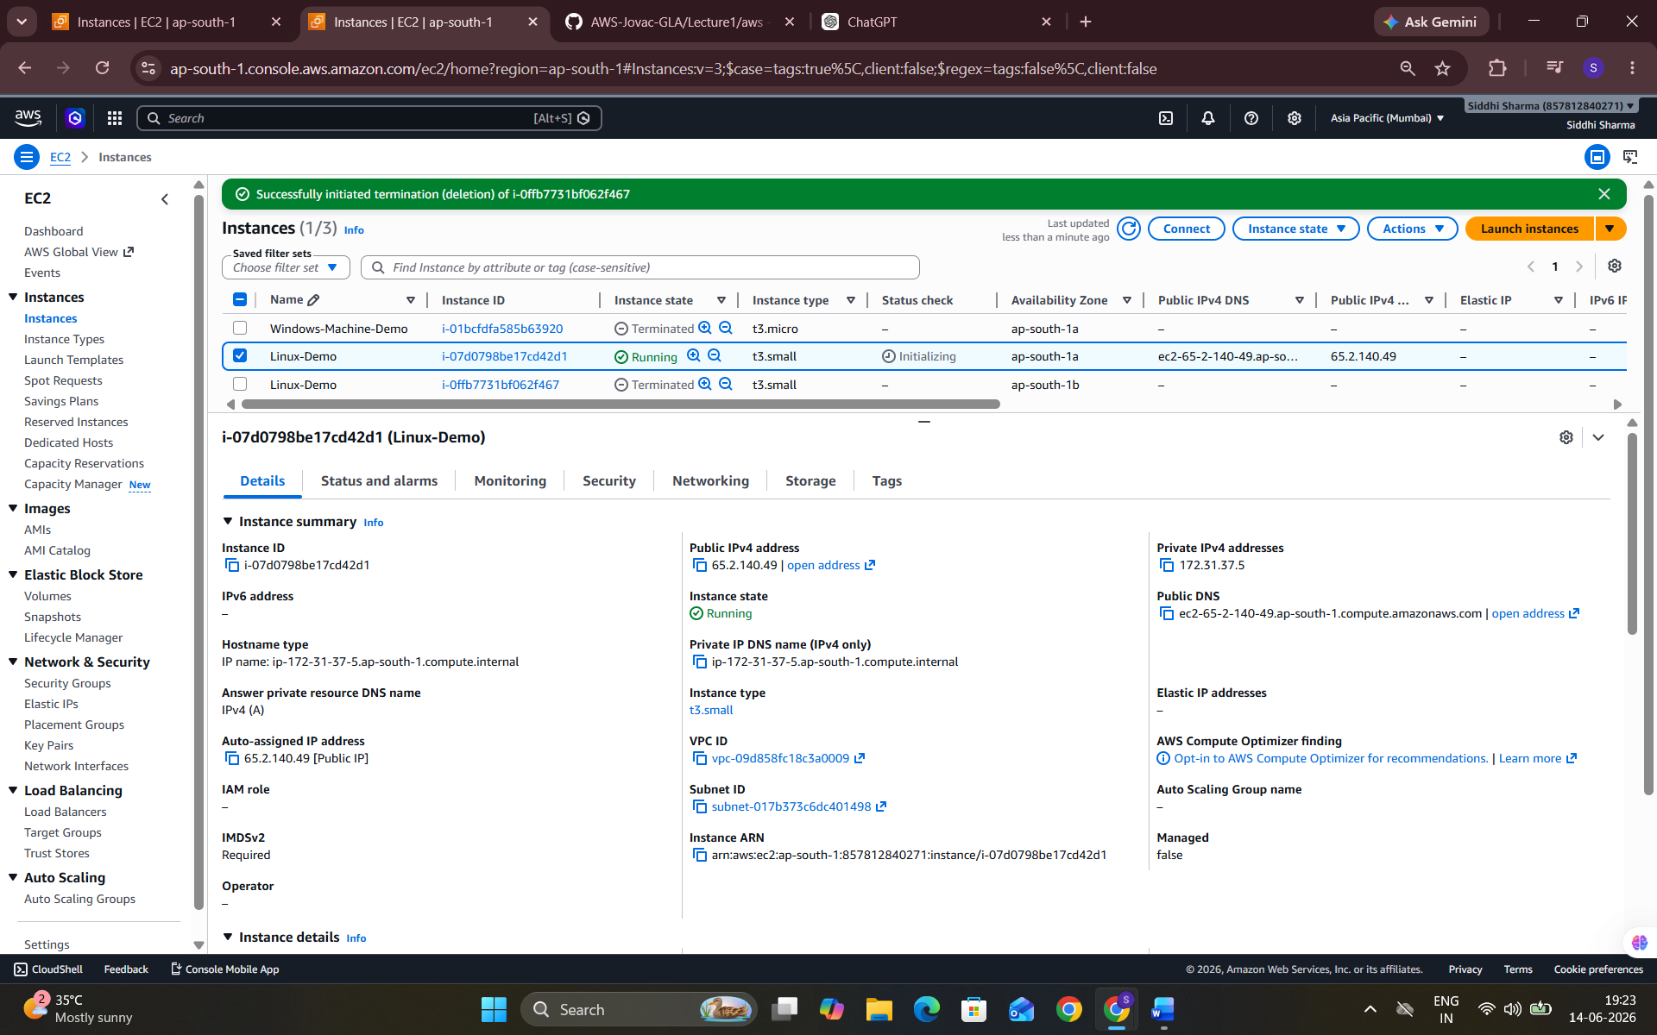

access a linux machine in EC2

- Use public Ip to access instance
- Add SSH inm security groups as RDP is only for windows machine SSH is used to connect Linux Machine
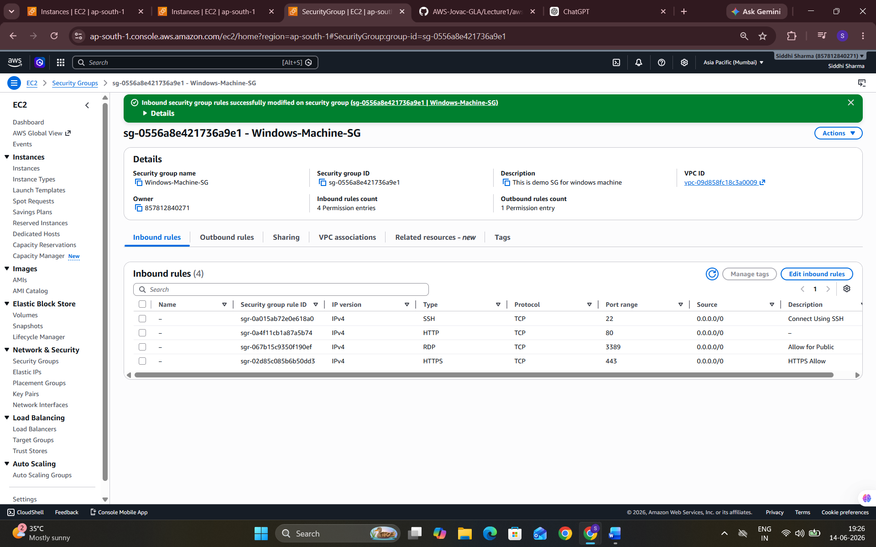
- For accessing we have to install a software Putty or Gitbash
- Here we download gitbash
- Locate your pem file (Private key file)
- Right click on empty space and click open gitbash here
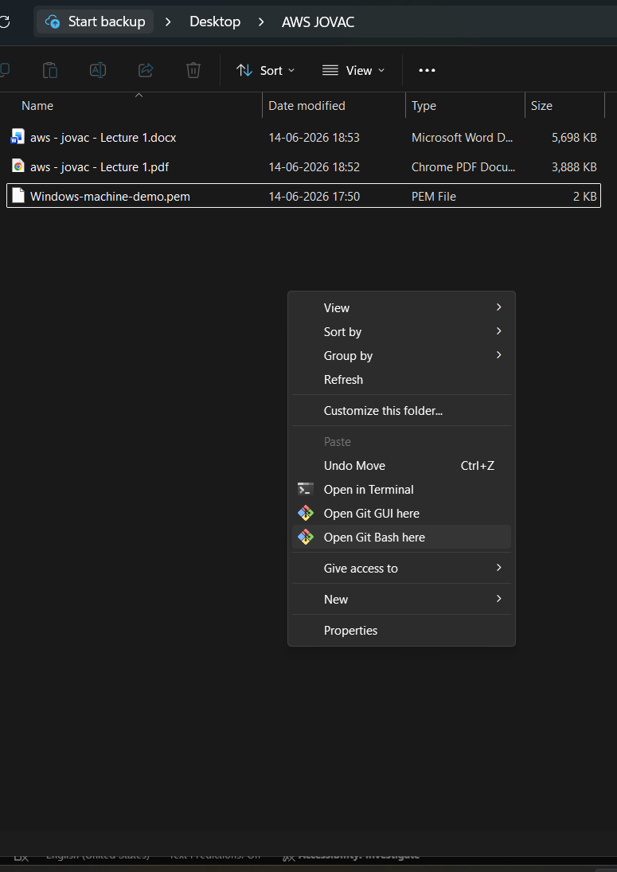
- Linux accessed
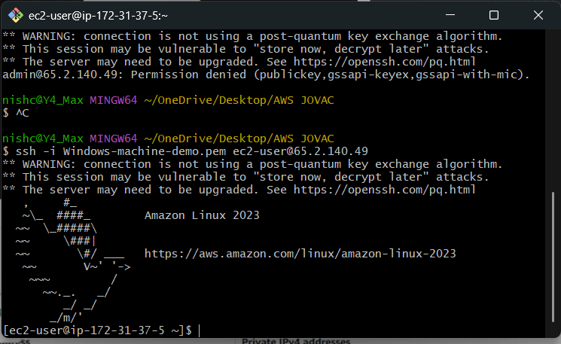
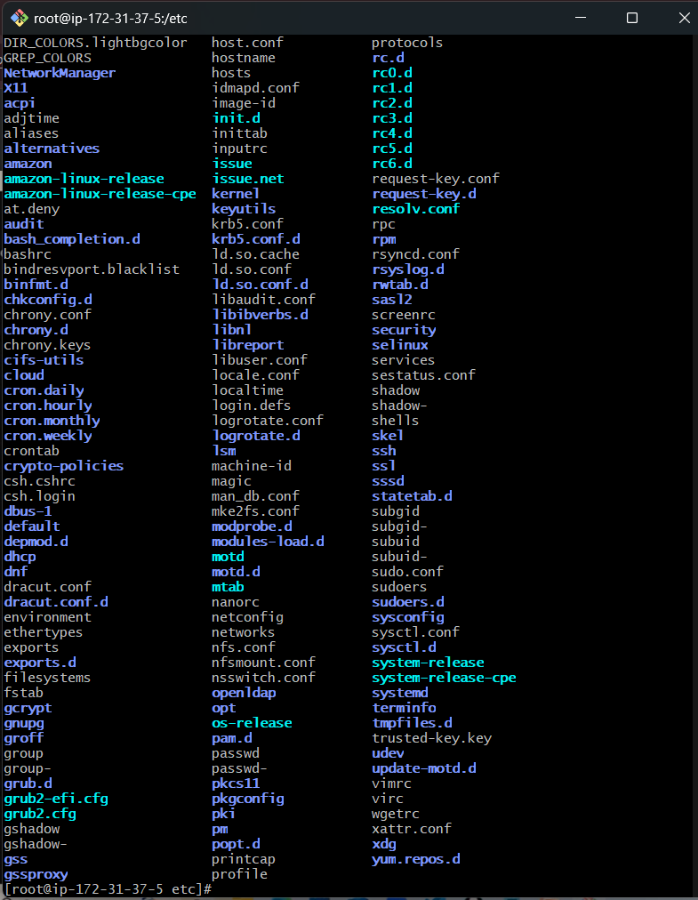
- Terminate the Instance
